**1. What are the different margins options and do we adjust the margins of the excel worksheet?**

**2. Set a background for your table created.**

**3. What is freeze panes and why do we use freeze panes? Give examples.**

**4. What are the different features available within the Freeze Panes command?**

**5. Explain what the different sheet options present in excel are and what they do**

**A1.** To use predefined margins, click Normal, Wide, or Narrow.

If you previously used a custom margin setting, that setting is available as the Last Custom Setting option. To specify custom page margins, click Custom Margins and then—in the Top, Bottom, Left, and Right boxes—enter the margin sizes that you want.

**A2**. The background color of the table is given by the bgcolor="color" attribute. When applied to the <table> tag, the color fills the background. Cell background colors are set by applying the bgcolor attribute to a <tr> tag (to color the row) or to a <td> tag (to color the cell).

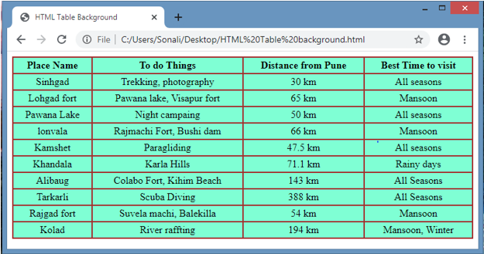

**A3.** Freeze Panes is a useful tool located in View Bar. In larger sheets, we have the data headers in the top rows and first columns. And on scrolling down or to the right, these headers do not appear.

The Excel Freeze Panes tool allows us to freeze the column/row or multiple columns/rows headings so that when we scroll down or move to the right to view the rest of the sheet, the rows/columns are that are frozen remain on the screen. After freezing, below that row and column, a grey line appears to make the partition.

Freeze Top Row:

On clicking Freeze Top Row, the First row gets frozen and on scrolling down, we can still see the

top Row throughout the pages.

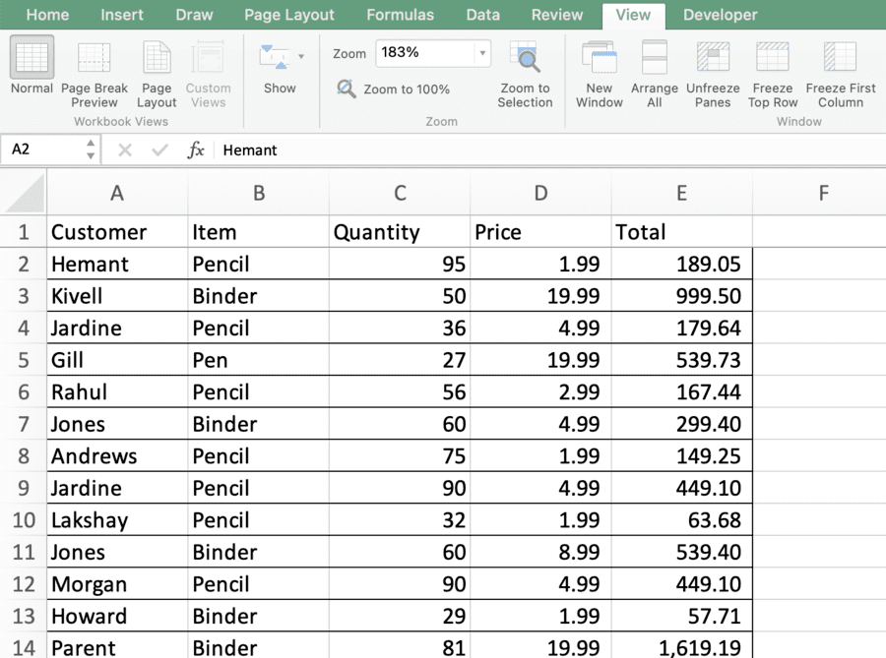

Freeze First Column:

On clicking Freeze First Column, the First Column gets frozen and on moving to the right, we can still see the First Column and can match the data values to the headers present in the first column.

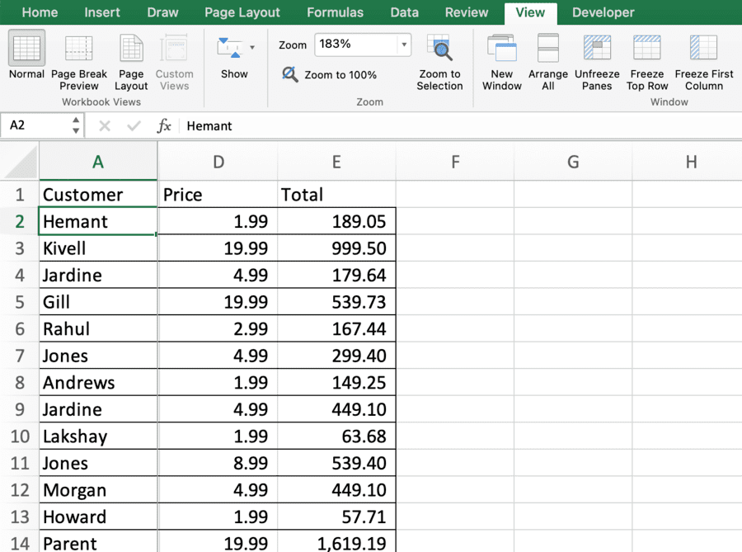

**A4**. If you apply the Freeze Pane option of Excel freeze pane feature, it can freeze the row and column simultaneously at the same time.

Freeze pane. ...

Freeze Top row. ...

Freeze First column.

**A5**. By default, when we create a new Excel file, it usually has three sheets, namely Sheet1, Sheet2, and Sheet3.  
  
We can adjust preferences from sheet options to include the gridlines to print and manage other sheet options.

Print Area − You can set the print area with this option.

Print Titles − You can set titles to appear at the top for rows and at the left for columns.

Print −

Gridlines − Gridlines to appear while printing worksheet.

Black & White − Select this check box to have your color printer print the chart in black and white.

Draft quality − Select this check box to print the chart using your printer’s draft-quality setting.

Rows & Column Heading − Select this check box to have rows and column heading to print.

Page Order −

Down, then Over − It prints the down pages first and then the right pages.

Over, then Down − It prints right pages first and then comes to print the down pages.